**HOW TO SEARCH OWNER & MEMBERS OF GROUPS**

Go to [itAccess.pg.com](https://pgglobalenterprise.service-now.com/itAccess.pg.com)

To view owner and member of groups, click on the menu items (https://pgglobalenterprise.service-now.com/sys_attachment.do?sys_id=92e83a95dba08894dcc82ad94b96196d) from the upper left side of the screen. Choose ’Manage Identity’ and click on ’View Identity’.

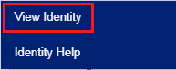

Choose user account who is already member of group and click on ‘Manage’.



Choose ‘Access’ from the left menu tab.

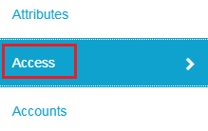

Under the entitlements section, type ‘memberOf’ and click on search to display the groups you are a member of.

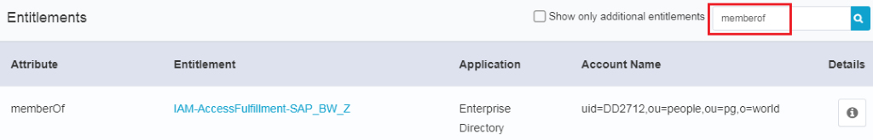

For more information on the group owner, click on the entitlement name. You will be able to see owner of the group by clicking on the ‘Standard Properties’ tab.

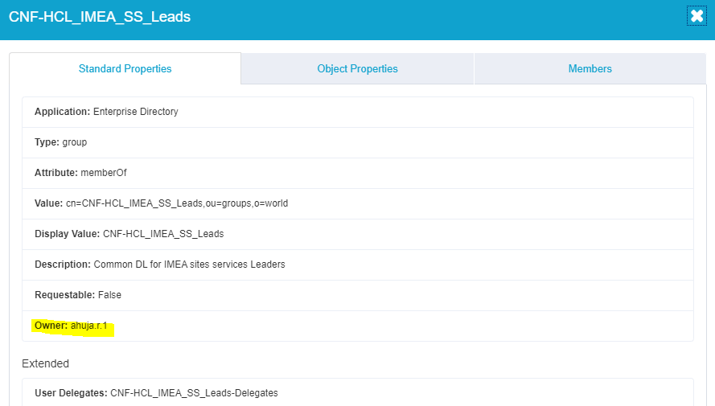

Information of delegate of group, click on the entitlement name. You will be able to see delegate of the group in below by clicking on the ‘Object Properties’ tab.

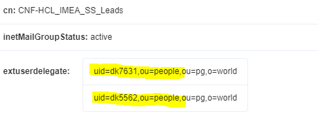

Information of Members of group, click on the entitlement name. You will be able to see Members of the group in below by clicking on the ‘Members’ tab.

